## CSE100 Fundamentals of Computer Programming

## Project Design Document

## Group-10

## Section-3

**Team Member 1 :**

Enrolment No. - AU2140161

Name - Mihir Kotecha

Programme - B-Tech CSE (Section-3)

**Team Member 2 :**

Enrolment No. - AU2140162

Name - Krutarth Vora

Programme - B-Tech CSE (Section-3)

**Team Member 3 :**

Enrolment No. - AU2140166

Name - Nisarg Patel

Programme - B-Tech CSE (Section-3)

* **User Interface Design :**
* Design of Authentication Phase as different Roles

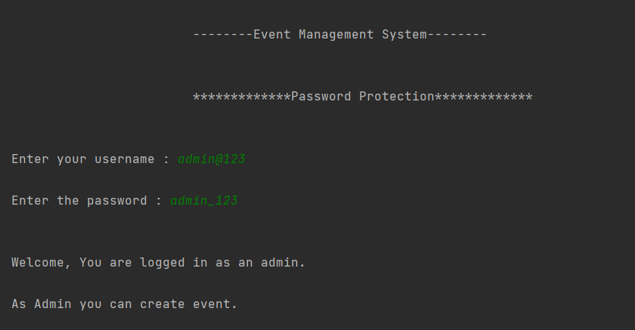 **(1)** **Admin :**

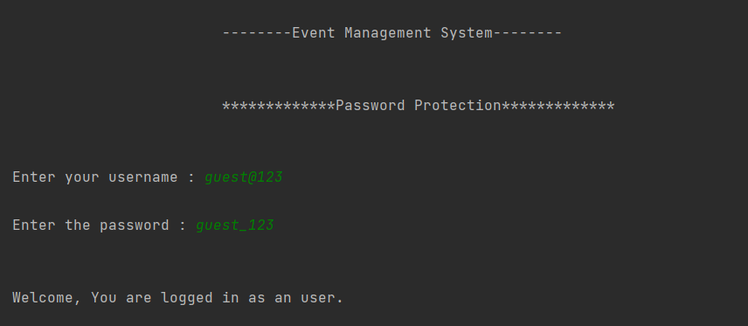 **(2) User :**

* 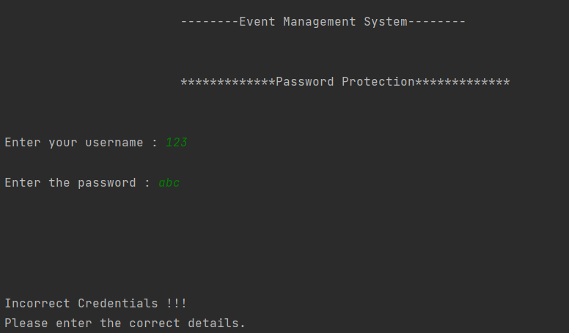**Invalid Credentials :**

1. **Create Event Module**

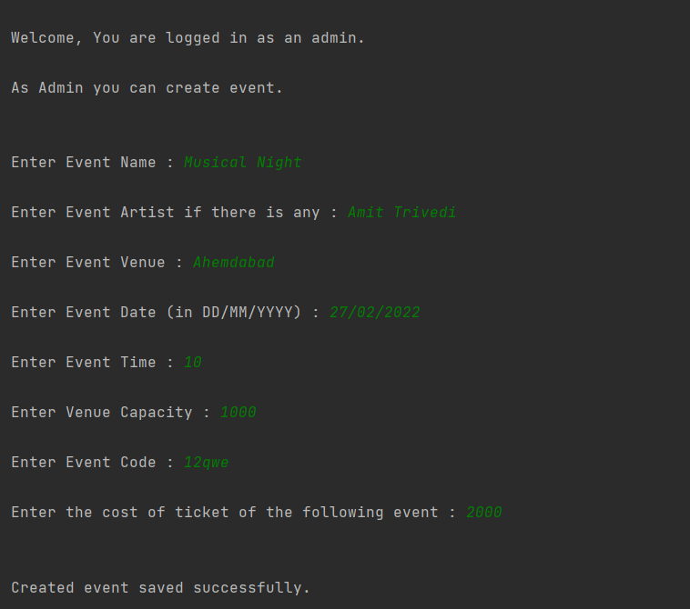

* **User Features :**

1. 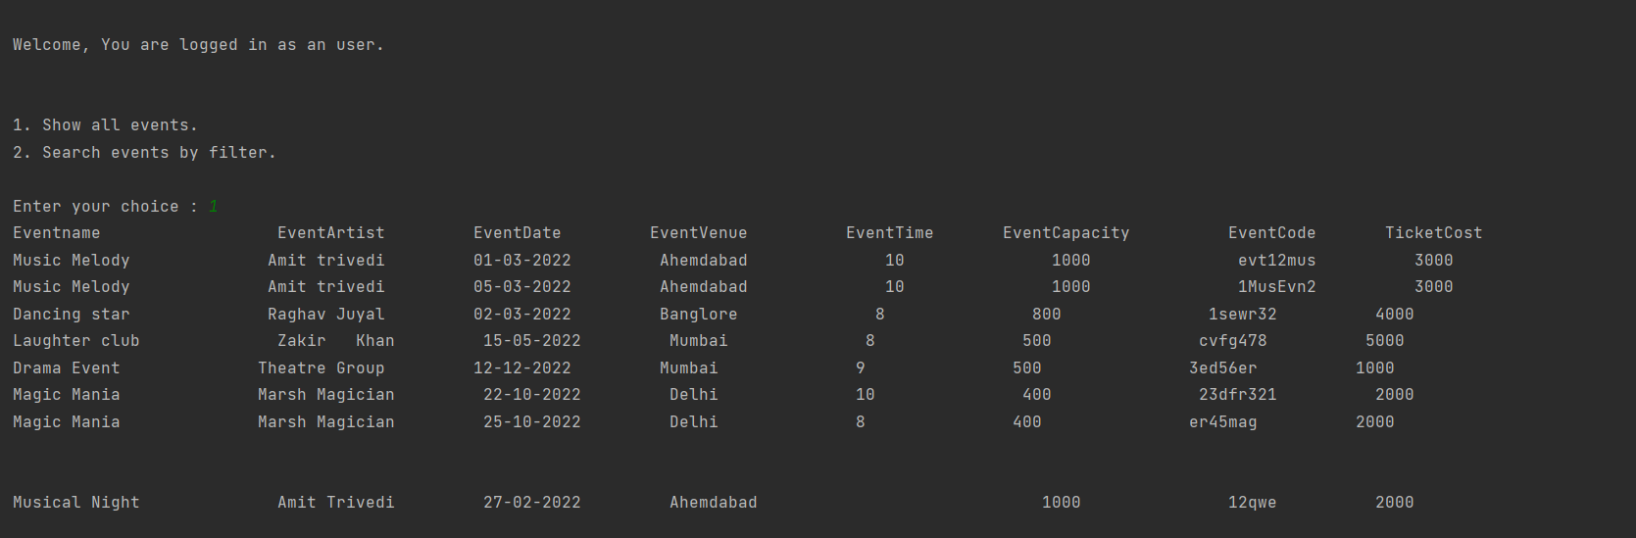**Show Events**

**2. Search by filters**

1. 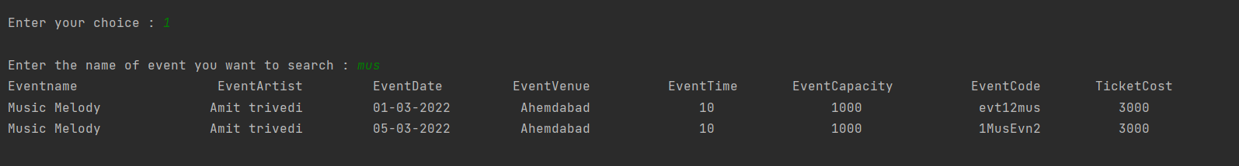**Event Name**

1. 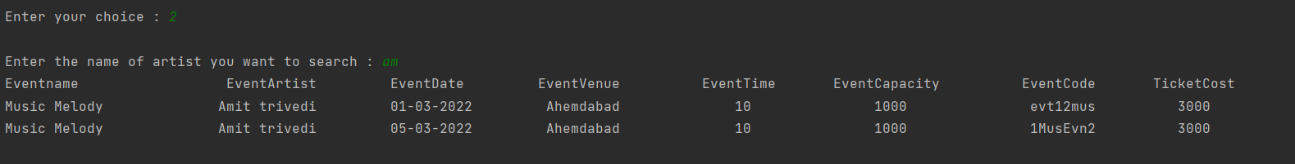**Artist Name**
2. 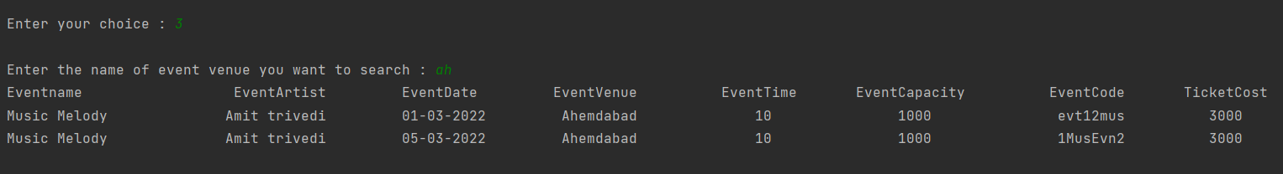**Venue**
3. **Book Tickets**

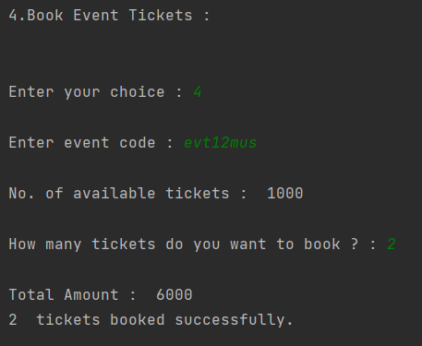

* **Structure Chart :**

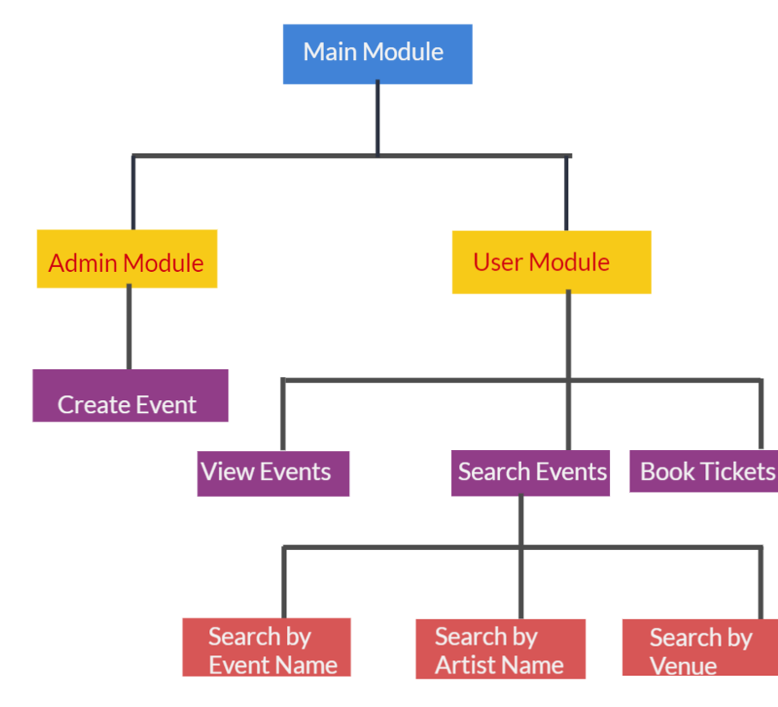

* **Algorithm :**
* Password Validation :
* Step -1: Ask for the user for Id and Password.
* Step -2: If credentials are correct then According to Credentials Entered Menu will be displayed. If credentials are incorrect then validation will be displayed.
* Admin functionalities:
* Step -1: Take the user input for the event name.
* Step -2: Take the user input for the artist of the event.
* Step -3: Take the user input for the venue of the event.
* Step -4: Take the user input for the date of the event.
* Step – 5: Take the user input for the time of the event.
* Step -6: Take the user input for the capacity of the event.
* Step -7: Ask for a unique event code.
* Step -8: Ask for the entry price.
* Step -9: Save all the information stored by the admin in the csv files.
* User functionalities:
* Step -1: Show the user option
  + 1- To see all the events
  + 2- To Search an event using filter.
* Step -2: If the user chooses option 1 print all the events available in the csv file.
* Step -3: If the user chooses option 2 show the options to search by
  + 1- Search By event name 🡪 Go to Step 3.1
  + 2- Search by event artist 🡪 Go to Step 3.2
  + 3- Search by event venue 🡪 Go to Step 3.3
  + 4- Book Tickets 🡪 Step -4.1

Step – 3.1

1. Take user input for search query and compare it to Event Name Stored in CSV Files.
2. Filtered Events will be available
3. User will be prompted for continuing to main menu or exiting from Application.
4. If User Chooses to Continue to main menu then it will Display Menu as mentioned in Step 1 of User Functionalities.

Step – 3.2

1. Take user input for search query and compare it to Event Artist Stored in CSV Files.
2. Filtered Events will be available
3. User will be prompted for continuing to main menu or exiting from Application.
4. If User Chooses to Continue to main menu then it will Display Menu as mentioned in Step 1 of User Functionalities.

Step 3.3

1. Take user input for search query and compare it to Event Venue Stored in CSV Files.
2. Filtered Events will be available
3. User will be prompted for continuing to main menu or exiting from Application.
4. If User Chooses to Continue to main menu then it will Display Menu as mentioned in Step 1 of User Functionalities.

Step 4.1

1. User will be prompted to Enter Event Code for which ever Event he/she wants to book ticket for.
2. Then user will be prompted to enter no of tickets he/she wants to Book for Event and also no. of available tickets for event is also shown.
3. If Tickets for Booking entered by User are more the available tickets then it will throw validation and it will prompt user to either go to main menu or exit.
4. If tickets for booking are less then No. of available tickets then tickets will be booked and Amount for those tickets will be printed on the screen.
5. User will be prompted to Continue to main menu then it will Display Menu as mentioned in Step 1 of User Functionalities.